# Arrays

# Calculate sum & product of all numbers in an array

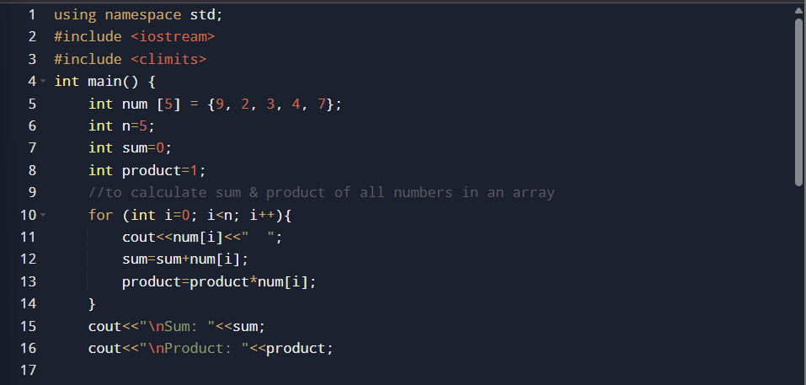

# Swap the max and min number of an array

# Print all the unique values in an array

# Output:

